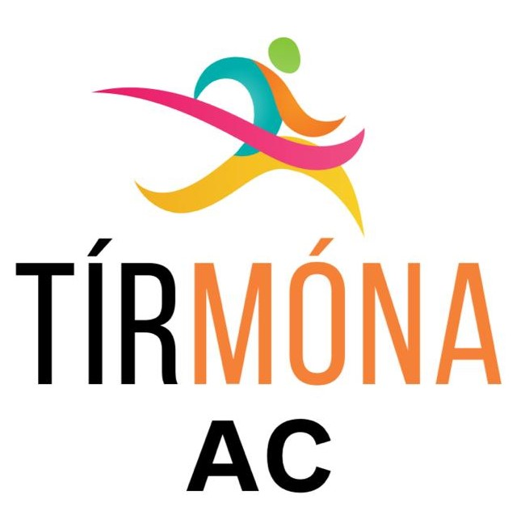

Tír Móna Athletic Club
Club Constitution

1. Name
The club will be called Tír Móna Athletic Club and will be affiliated to the Athletic Association of Ireland (AAI).
All club members including committee members, coaches and volunteers shall register annually with the Athletic Association of Ireland and will be subject to the rules and regulations of the AAI.
The club shall register club colours with the AAI, which shall confirm with IAAF/AAI rules.
The club shall be in affiliation with its appropriate County Board and Provincial Council of the Athletic Association of Ireland.

2. Aims and Objectives
The aims and objectives of the club will be:
- To participate and compete in the sport of Athletics including track and field, cross country, road running and race walking.
- To offer coaching and competitive opportunities in Athletics.
- To promote Athletics within the local community.
- To ensure a duty of care to all members of the club.
- To provide all its services in a way that is fair and ethical to everyone.
- To ensure that all present and future members receive fair and equal treatment.

3. Membership
Membership should consist of officers and members of the club consisting of the following categories:
- Adult members.
- Juvenile members.
- Committee members.
- Non-athletic members.
All members will be subject to the regulations of the constitution and by joining the club will be deemed to accept these regulations and codes of conduct that the club has adopted.
Any application form for membership should contain a clause whereby the applicant consents for the purpose of the Data Protection Act, to the Club holding and processing the data on the form for the purposes of the Club.
All members joining the Club shall be deemed to accept the terms of this Constitution and any Bye-laws from time to time adopted by the Club. They will also be required to conduct themselves in accordance with the Club's ethical framework and the bye-laws as to discipline set out therein.
Any person seeking to join the Club shall submit an application in writing to the Executive Committee.
Members shall be admitted by the Executive Committee. Membership is open to all and no application for membership will be refused on other than reasonable grounds. There will be no discrimination on grounds of race, occupation or gender.
The Secretary shall keep a Membership Register. In the event of a member’s resignation or expulsion, his or her name shall be removed from the Membership Register.
All members will be registered with Athletics Ireland

4. Membership fees
Membership fees will be set annually and agreed by the management committee or determined at the Annual General Meeting. Fees will be paid: annually and / or by weekly subscription.
The Club in General Meeting may also require Members to contribute to the funds of the Club by way of a special levy.

5. Officers of the club
The officers of the club shall be honorary (non-paid) and will be made up of the following:
- Chairperson
- Vice Chairperson
- Secretary
- Treasurer
- Registrar
- Child Welfare Officer
- Public Relations Officer
All Committee members must be members of the Club. Committee Members shall hold office from the date of appointment until the next Annual General Meeting unless otherwise resolved at a Special General Meeting. One person may hold no more than two positions of Club Officer at any time.
The Club Committee shall be responsible for the management of all the affairs of the Club.
Decisions of the Club Committee shall be made by a simple majority of those attending the Club Committee meeting. The Chairperson of the Club Committee meeting shall have a casting vote in the event of a tie.
Meetings of the Club Committee shall be chaired by the chairperson or in their absence a nominated committee member.
The quorum for the transaction of business of the Club Committee shall be a minimum three.
Decisions of the Club Committee of meetings shall be entered into the Minute Book of the Club to be maintained by the Club Secretary.
Any member of the Club Committee may call a meeting of the Club Committee by giving not less than 7 days notice to all members of the Club Committee.
The Club Committee shall hold not less than four meetings a year.
All offices will retire at the AGM each year but an outgoing member of the Club Committee will be eligible to stand for re-election. Any vacancy on the Club Committee which arises between Annual General Meetings shall be filled by a member proposed by one and seconded by another of the remaining Club Committee members and approved by a simple majority of the remaining Club Committee members.
The Club Committee shall have the power to decide all questions and disputes arising in respect of any issue concerning the Club Rules.

6. General Meetings
The Annual General Meeting usually fulfils the basic purposes of electing officers and other members of the Executive Committee, of reviewing the Accounts and of considering other matters of importance to the Club membership. It also considers changes to the Constitution.
The Club shall hold an Annual General Meeting in the month of February to:
- Approve the minutes of the previous year’s AGM.
- Receive reports from the Chairperson and Secretary.
- Receive a report from the Treasurer and approve the Annual Accounts
- Elect the Executive Committee.
- Appoint someone responsible for certifying the Club’s accounts.
- Fix the subscription for the ensuing year.
- Consider changes to the Constitution.
- Review and consider any Bye-laws.
- Deal with other relevant business.
- Nominations for election of members as Club Officers shall be made in writing by the proposer and seconder, both of whom must be existing members of the Club, to the Club Secretary not less than 21 days before the AGM.
- Notice of any resolution to be proposed at the AGM shall be given in writing to the Club Secretary not less than 21 days before the Meeting.
- A Special General Meeting (SGM) may be called at any time by the majority of the Committee. 10% of the Club Members may also call such a meeting. The meeting must take place within 21 days of the Secretary receiving notice of the request. Business at an SGM may be any business that may be transacted at an AGM.
- The Secretary shall inform each member using their registered contact details of the date of a General Meeting together with the resolutions to be proposed at least 14 days before the meeting.
- The quorum for a General Meeting shall be 10.
- The chairperson, or in their absence a member selected by the Club Committee, shall take the chair. Each member present shall have one vote and resolutions shall be passed by a simple majority. In the event of an equality of votes the Chairperson of the Meeting shall have a casting vote.
- The Club Secretary, or in their absence a member of the Club Committee, shall enter Minutes of General Meetings into the Minute Book of the Club.

7. Finance and Accounts
The financial year shall run from January to December each year.
The Treasurer shall be responsible for the preparation of Annual Accounts of the Club.
The Accounts shall be certified by an appropriate independent person elected annually at the Annual General Meeting.
All cheques drawn against the Club’s funds shall be signed by the Treasurer and one of two other nominated office-bearers.
All members of the Club shall be jointly responsible for the financial liabilities of the Club.

8. Coaching, Training & Competition
The Club Committee shall appoint a coach / coaches to be responsible for the training of the athletes. It will be up to the nominated coach / coaches to select the day and time for training.
A coach will be nominated to be responsible for athletes at each competition meet throughout the year. The appointed coach / coaches shall be responsible for managing the affairs of the athletes for the duration of the meet.
All coaches will be required to attend the necessary training courses and to comply will all safety and child protection regulations.

9. Dissolution
The Club is a non-profit making organisation. All profits and surpluses will be used to maintain or improve or develop the Club's facilities or to carry out the objects of the Association to which it is affiliated. No profit or surplus will be distributed other than to another non-profit making body on a winding-up or dissolution of the Club.
If, upon the winding up or dissolution of the Club there remains after the satisfaction of all its debts and liabilities any property whatsoever, the same shall be transferred to some other organisation or organisations having objects similar to the objects of the Club, such organisation or organisations to be determined by the members of the Club by Resolution passed at a General meeting or in the absence of such a resolution (or that the extent to which it cannot be given effect) to the Association to which the Club is affiliated to.

10. Trustees
The club should have a minimum of three and a maximum of six trustees on the club grounds at Upper Hodgestown, Donadea, Naas, Co. Kildare, W91 AHF7.
A trustee cannot be a member of the club committee or an appointed official of the club.
Trustees can only be appointed at an annual general meeting and the appointment of a trustee must be a unanimous vote.
A trustee must also give a minimum of 2 months notice if they intend to resign as trustee of the club grounds at Upper Hodgestown, Donadea, Naas, Co. Kildare, W91 AHF7.

